The Blurb of

Caren Reid, Sim Tech

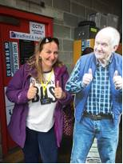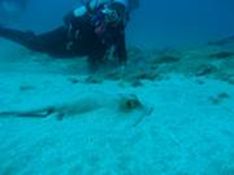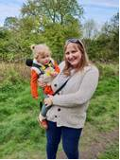 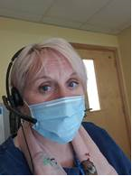 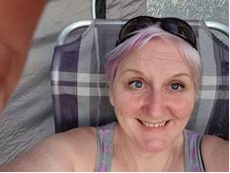

As well as a Sim Tech, I’m a wife, Mum of 2 & Nana of the amazing Lilliana, a scuba diving, motorbike and scooter riding, clay pigeon shooter who loves Emmerdale, my hot tube, holidays, my newly acquired motor home and Gin I like Gin.

In January 2011 I was employed as a Clinical Skills & Simulation Technician, with no previous experience or qualifications for the role. I had worked in Medical Education as a receptionist, study leave co-ordinator and a Team Leader in the Training department before moving to Mallorca for just under a year. The job sounded so interesting, and I was in the market having just moved back to the UK it was like it was fate.

It was all so new back then even the department didn’t know what they wanted or needed. So, I like to say my winning personality won me the position over IT bods who were the only other applicants. I was very lucky as the Lead at the time was very pro simulation and realised it would take someone with a bit of umph and attitude definitely not a wall flower… enter stag left….Me 😊

I was pretty much left to my own devises and I had to learn everything from scratch. Apart from some fabulous reps from the various companies, who kindly came in and spent time going over their equipment with me, I mostly self-trained. I started my career on a band 3 where I stayed for 8 years despite mostly running the service on my own. I have had 3 Simulation Leads 2 were consultants who was contracted to spend 4 hours a week in Simulation and one was employed for 3 years 3 days a week on a much higher banding.

I joined the YHCSSN (Yorkshire & Humber Clinical Skills & Simulation Network) steering group around 2017 as my Lead at the time was the Chair, this was really great for me as I started to present, chair meeting etc. which pushed me outside of my comfort zone. I was and still am a behind the scenes type I don’t like to stand in the spotlight. Attending conferences and meetings also helped me to see how good we were as a trust and how good I was as a technician. Sounds big-headed I know, but I realised people were shouting about doing things we had done ages before so gave me a real confidence boost.

Some time ago Jane Nicklin ran a pilot scheme for an apprenticeship for Techs which I joined as well as working full time in post already, where I gained a diploma in Educational Science. This was a biggy for me as I am so not academical at all I hated school, I actually missed a lot of schooling so wasn’t very good at it and unsurprisingly left with the bare minimum mid-grade GCSE’s. But after my diploma I decided to apply for professional registration and was awarded RSci Tech in May 2018 this was really important to me it was validation of all the hard work I had put into both staff training and my own development.

This helped me realise I needed to be re-banded not only for the money (always helps) but recognition of what I give to the Trust. So, I went through the process of re-grading this was really hard and felt like I was just banging my head against the preverbal wall. BUT I eventually managed to secure a band 5 after lots of wrangling with HR in 2019.

On the job driving

Bing or Dickie

Fast forward to end of 2019 and ASPiH advertised for a volunteer Tech for the Exec board, something I would never have gone for a few years ago. But thought why not I’ve got loads to offer and in March 2020 I received an offer letter. Unfortunately, I had just lost my Dad so wasn’t in a position to except but they said they were happy to wait a while for me to join and in June 2020 I came on board. It’s a lot of work I have no idea how Sam managed on her own for so long, but I do enjoy it, I enjoy working with Sam a fellow tech for Techs.

I am really proud of me; I am a registered professional! Next step RSci!

I work hard for all our staff ensuring fabulous training, I work hard to ensure my apprentice is learning everything he can, I work hard for all Techs out there as an Exec member. I didn’t realise the work behind the scenes at ASPiH before I joined I do now.

That’s what Techs do day in, day out work hard for the good of everyone else,k making sure the faculty and candidates/delegates get the best experience possible. So Sam and I decided to launch a #SimTechDay as a celebration of all our Technicians, a recognition day, a “you’re fantastic” day.

Unfortunately, we aren’t in a position to spend loads of money and make it a sparkling fireworks kind of day as they deserve but a shout out day.

As I write this blurb of Caren its National Paediatric Haematology/Oncology Nurses Day & National Ampersand Day!

Do I need to say more??

`

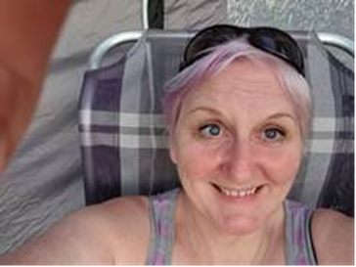 

Off the job, On holiday in the motor home possibly with Gin

😊