Sam’s Blurb



Hi, I’m Sam. Mum to four boys and partner of Benjamin Button ☺ . I enjoy holidays abroad, the sea, mobile phone photography, upcycling, festivals and raves 

In 2011 I was employed as a Laboratory Technician, after previously working in Secondary Education at an inner London Comprehensive School. The name laboratory conjures up all things in the imagination, however like a lot of technician roles, this role job title was incorrect.

Looking back, what shocked me most was that two of the people who went for the role were nurses. I’m not clinically trained at all, I have no nursing background. When I went for the interview I only had NVQ Level 4 and some qualifications I had gained while working as a teaching assistant. Getting the job, you would have thought would have given me confidence, on the contrary, I felt like an imposter.

Lab technician, positions lotions explosions…..I soon discovered the role was less about creating potions and more about supporting nursing students and setting up equipment for practical sessions.

After working in the role for six months I thought “I’ve made a huge mistake. The job wasn’t what I thought it was. I didn’t want to leave, so I decided to observe every single session I could to use my time wisely. In one session, the lecturer said to a student, “Pretend there is a wound on this arm.” I thought, why are they pretending? Why don’t I just put one on there? I’d never done anything like it before.

I submitted a business case, another first, to attend training in Casualty Make Up, this was successful and I embarked on the first of many training sessions.  I thoroughly enjoyed the training I received at Ealing Studios, and my love affair with *moulage really took hold.  Nothing like this had been done before at the university, however Moulage has proved to make a real difference to the student’s skills and simulation sessions. It was shortly after this that my alter ego ‘Moulage Mumma’ was created, more recently this venture has had to take a back seat due to lack of time. I am in a fortunate position of being able to choose where and when Moulage Mumma works.

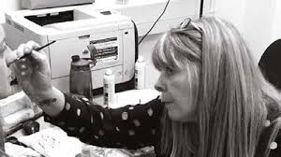

Feeling more confident in my role, I submitted another business plan to change my job title. After lots of discussions a new job title, Skills and Simulation Supervisor was created and I was in this post for five years.  During this time, I embarked on a 3-year part time Master’s Degree at The University of Hertfordshire, whilst working full time, and I graduated with a MSc Medical and Healthcare Simulation with distinction. Shortly after I applied for and was awarded the title fellow of the Higher Education Academy, I became a Registered Science Technician and was shortlisted for a Papin Prize award.  Although I didn’t win the award, I was commended for ‘Recognising Technical Excellence in Academia’

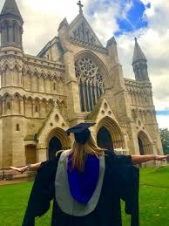

Again, another new post was created, (what is it with simulation technicians job titles) Skills and Simulation Facilities Team Lead, I applied and was successful.  In 2018, due to a restructure another new role was created ‘Technical Manager’, again, I applied and was successful, and I now lead a team of technicians, and we supported 1000’s of students each week who passed through twenty four simulation in a variety of practical sessions.

In 2019 I was named in the top [**100 individuals**](https://protect-eu.mimecast.com/s/FvOICz7NFROlOos4hGLB?domain=nam02.safelinks.protection.outlook.com) whose work at universities is saving lives and making a life-changing difference to health and wellbeing , this came about after devising a Dementia Simulation, that went on to win [**The SNTA 2018.**](https://protect-eu.mimecast.com/s/UQuZCAM7I9GyGAH8lHdO?domain=nam02.safelinks.protection.outlook.com)

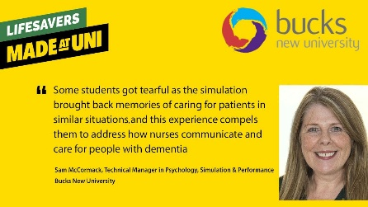

I have been shortlisted for The Papin Prize awards, being ‘Recognising Technical Excellence in Academia’

Learning never stops, I was the first Simulation Technician to gain professional Registration with The Science Council, and I have since become a Chartered Scientist.

I am the first Technician to become a voluntary Executive Committee member for The Association of Simulated Practice in Healthcare (ASPIH), where I lead all things Science Council.  I also dipped my toe in the world of Social Media, becoming the [**BMJ_STEL Social Media Editor.**](https://protect-eu.mimecast.com/s/fOG7CBP7fVzQz5IN4qBJ?domain=nam02.safelinks.protection.outlook.com)

I am pro technicians and continue to encourage the technical community to push boundaries and develop themselves in their role.  My previous team were Associate Fellows of the Higher Education Academy and two held professional Registration with The Science council and are also volunteer as applicant assessors.

The first ASPiH Conference I was involved in with the organisation side of things, I reached out to well know simulation suppliers to ask if they would sponsor a simulation technicians conference entrance fee, roll up [**Gorgon McLoughlin**](https://protect-eu.mimecast.com/s/6mD3CDQ7TBD2DlHZAyqa?domain=nam02.safelinks.protection.outlook.com) CEO at Scotia UK plc who sponsored not one but seven Simulation Technicians entrance into the Belfast conference.

In 2020, I assessed document’s for Health Education England ‘How to’ guides working with external networks to assess resource that clearly benefits the NHS community.



Most recently, I have embarked on a new role at Brunel University London, as a Technical Specialist – Clinical Simulation, I will keep you updated.